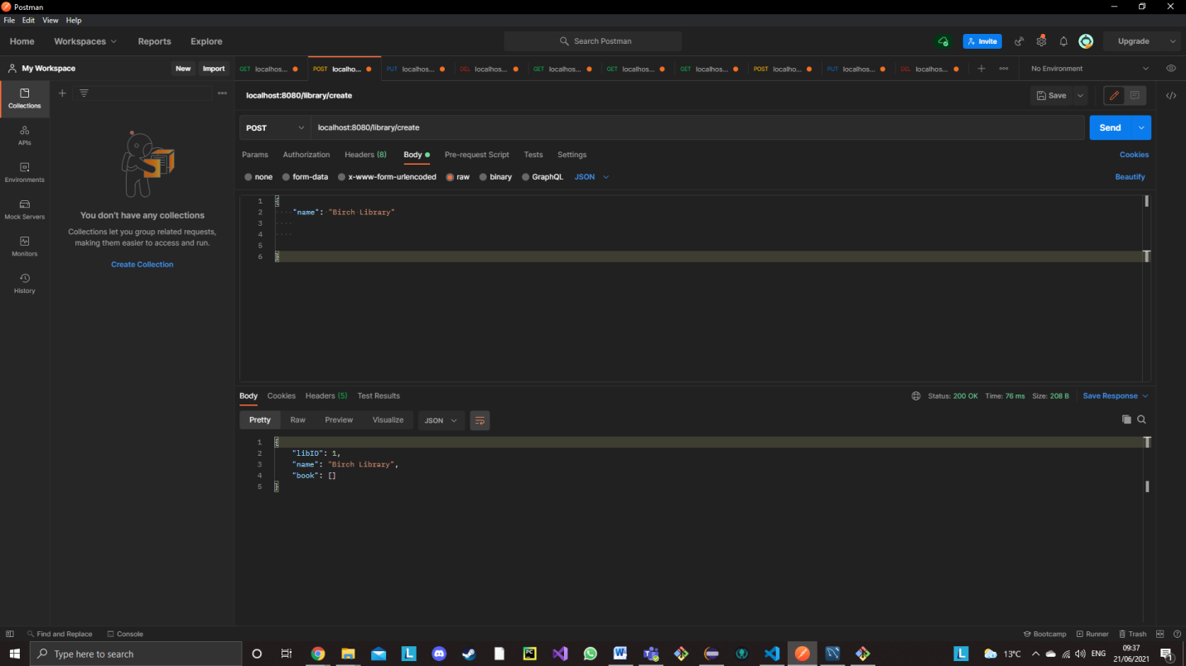**Postman Screenshots- Checking to ensure back-end crud is functional (example; Creating a library)**

**Postman Screenshots- Successful (Library Displayed on Webpage)**

